Oceanic Family Bonding, Maldivian Style

Five ways Four Seasons Resort Maldives at Kuda Huraa is a haven for families
September 20, 2024, Maldives at Kuda Huraa, Republic of Maldives

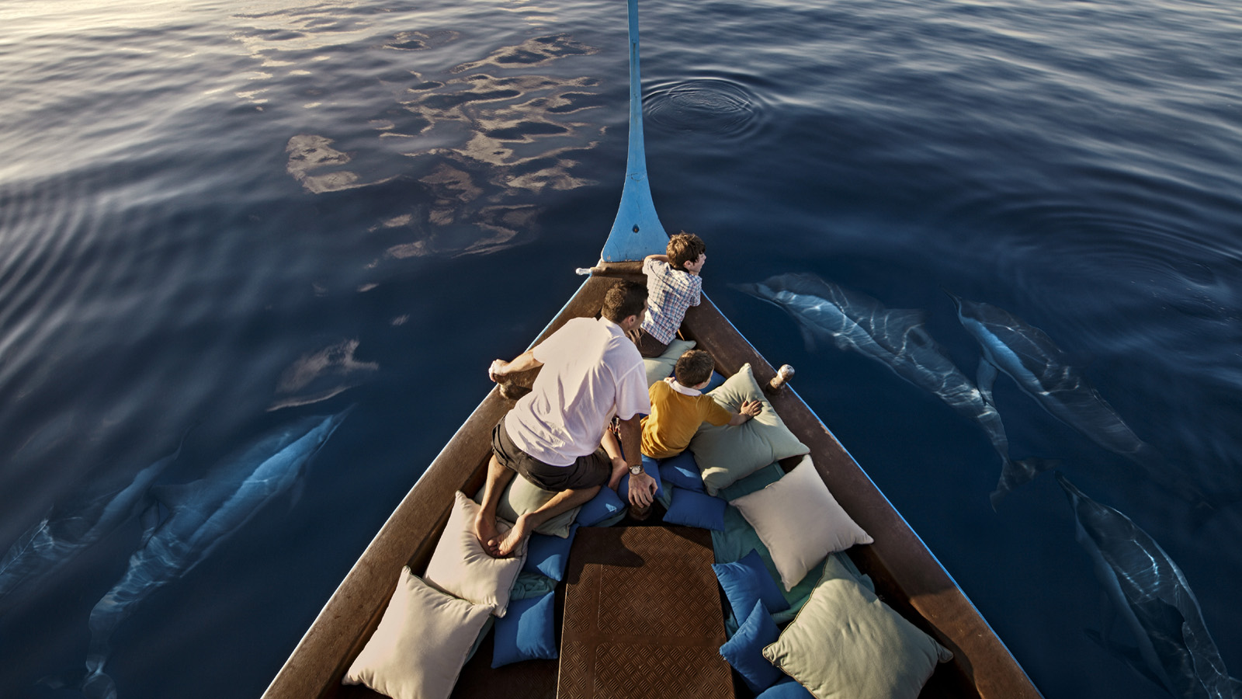
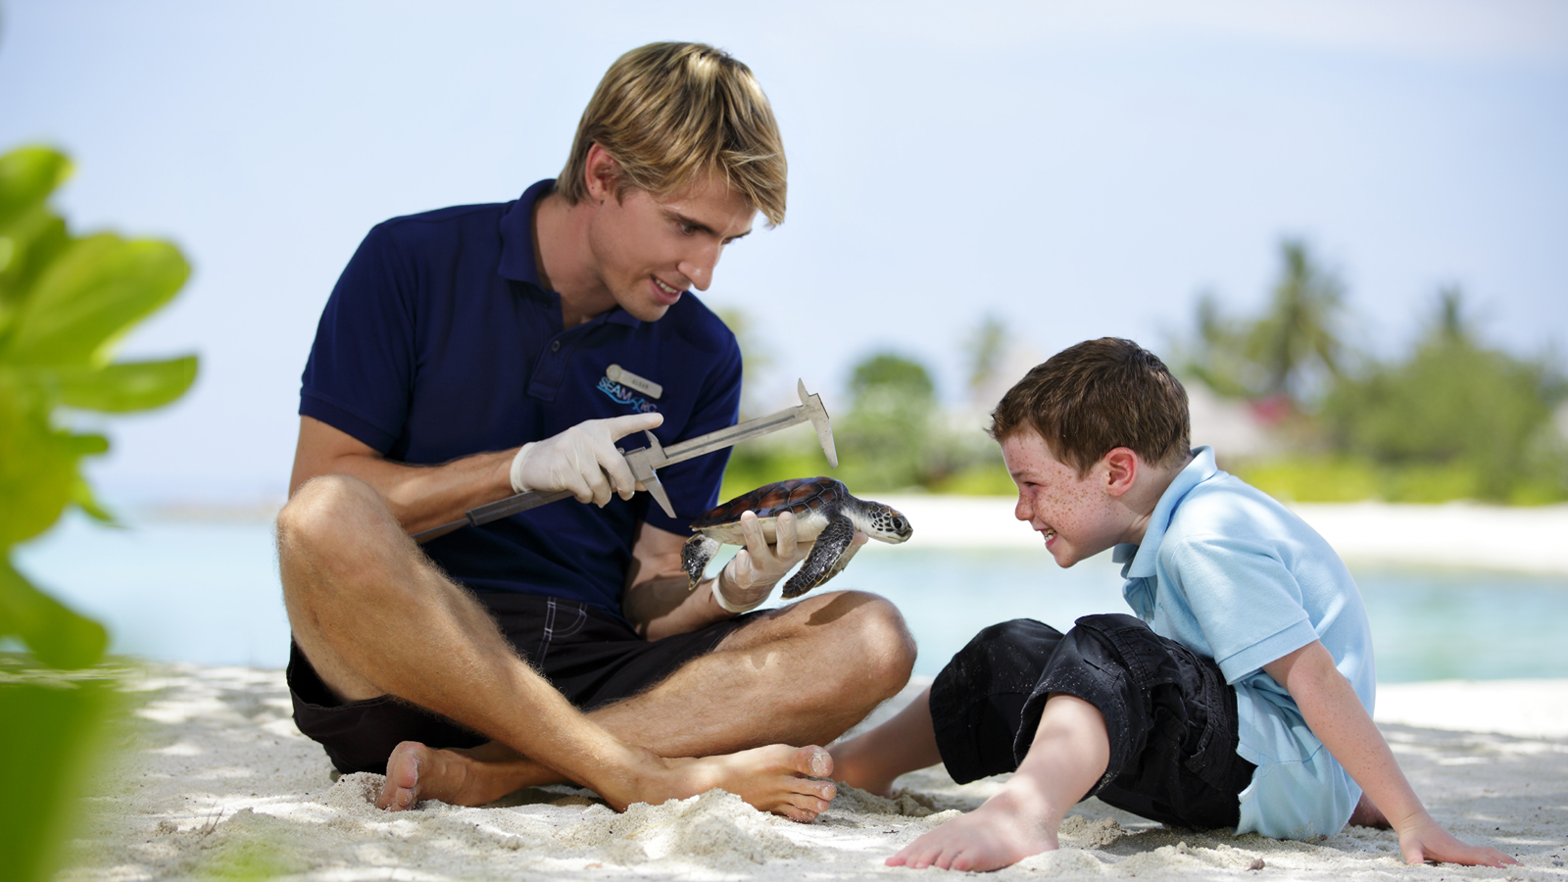 | 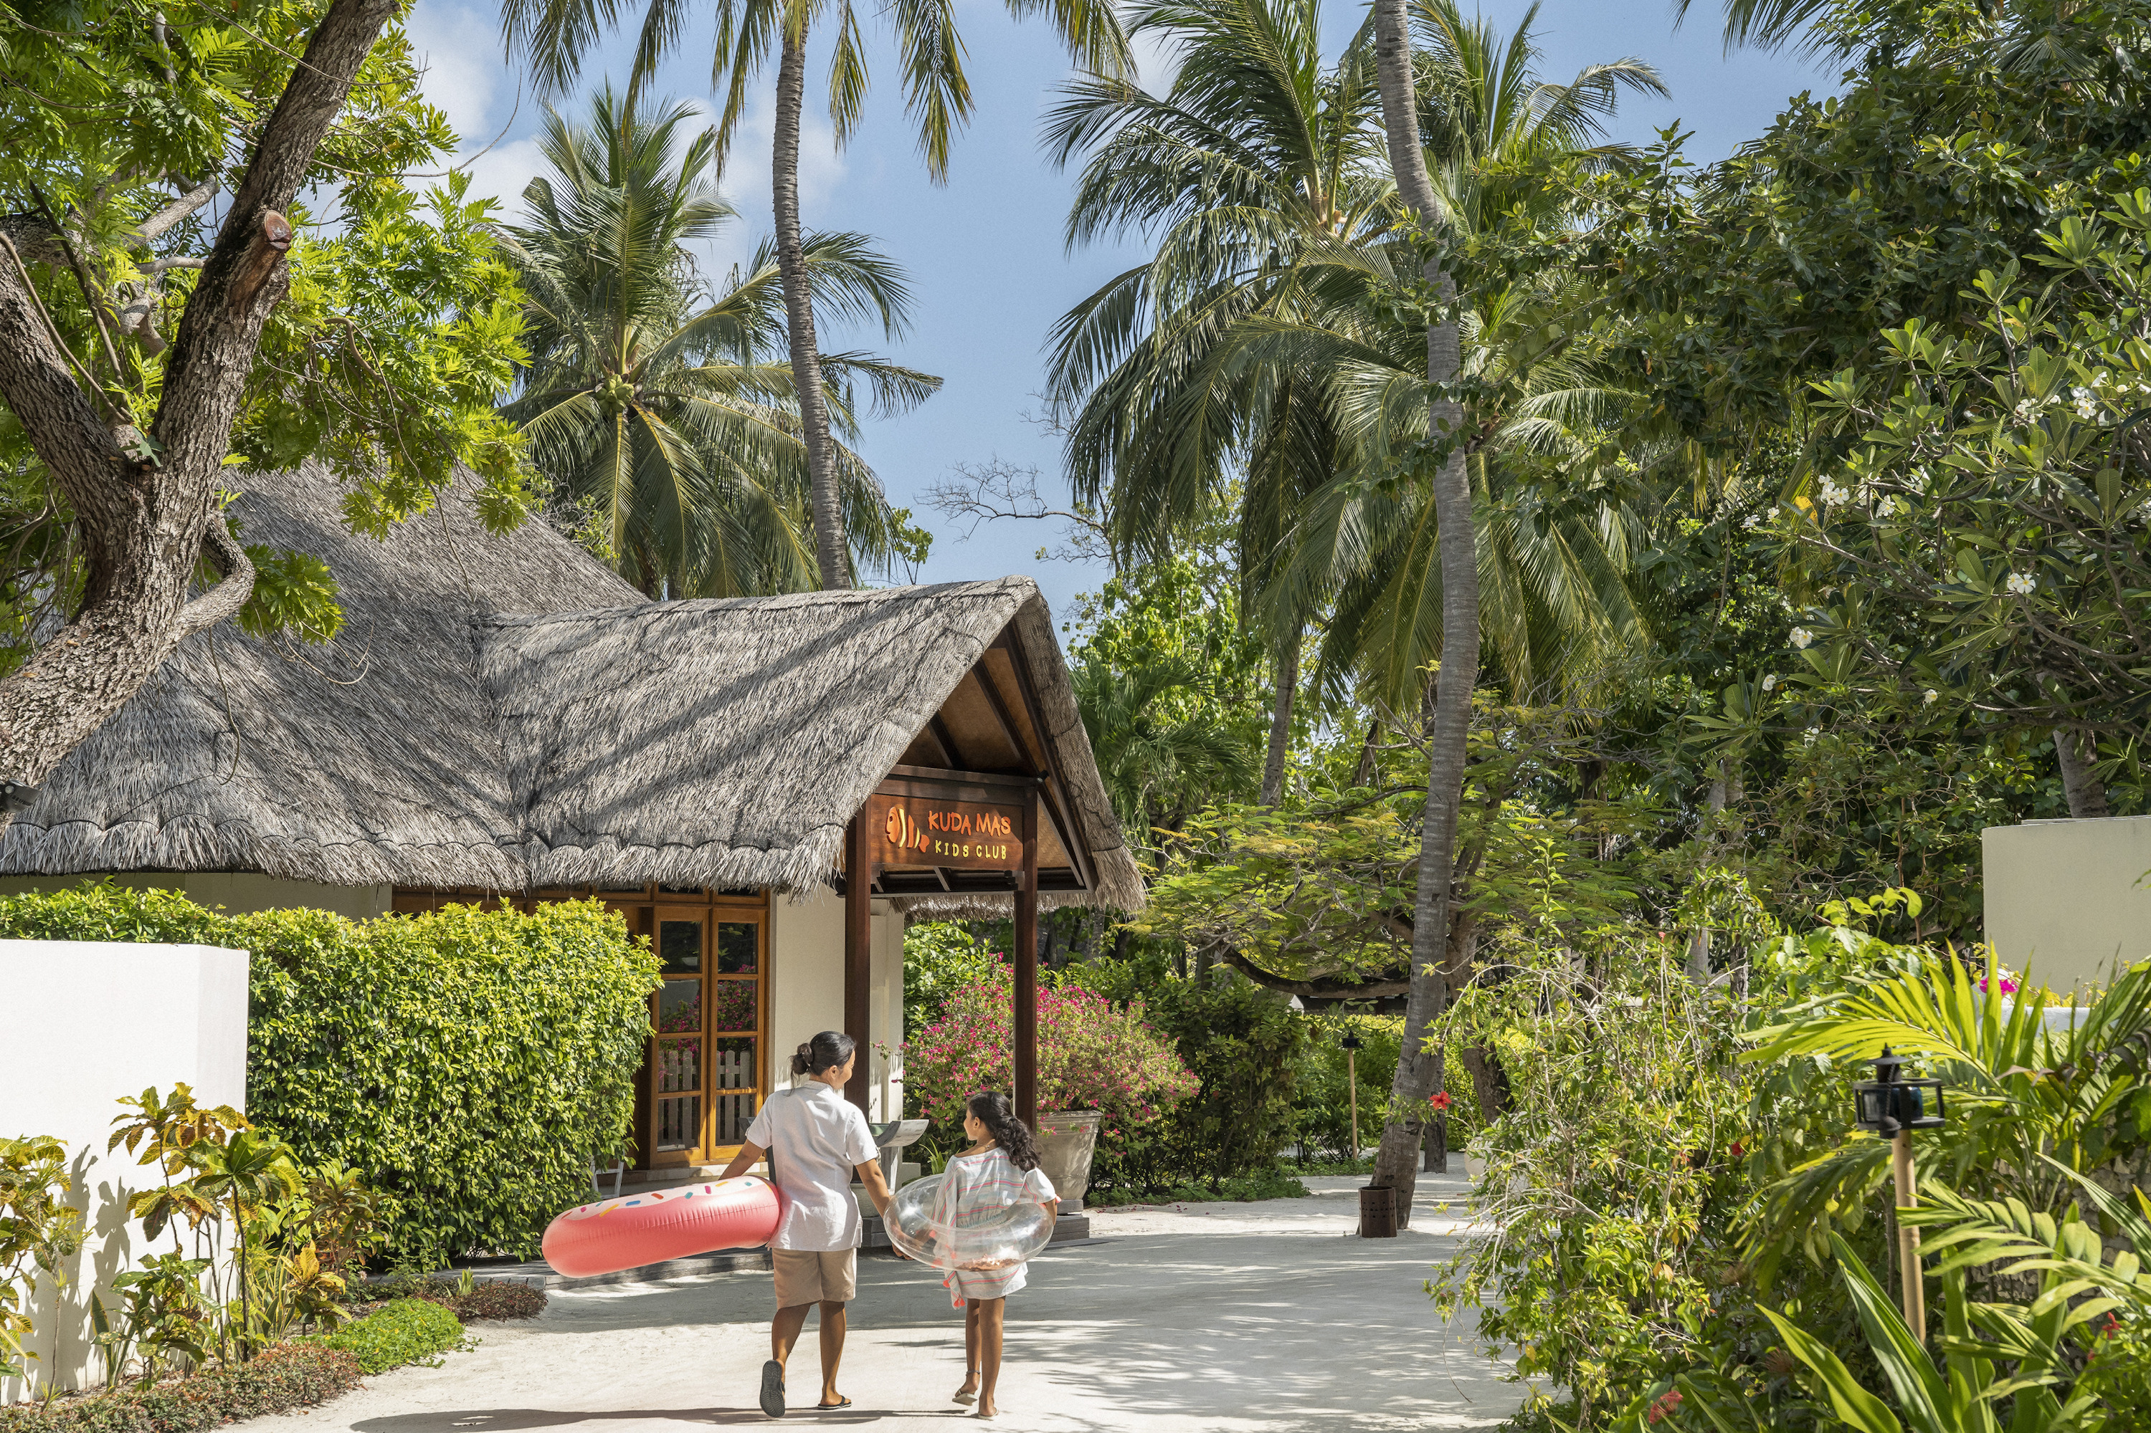 | 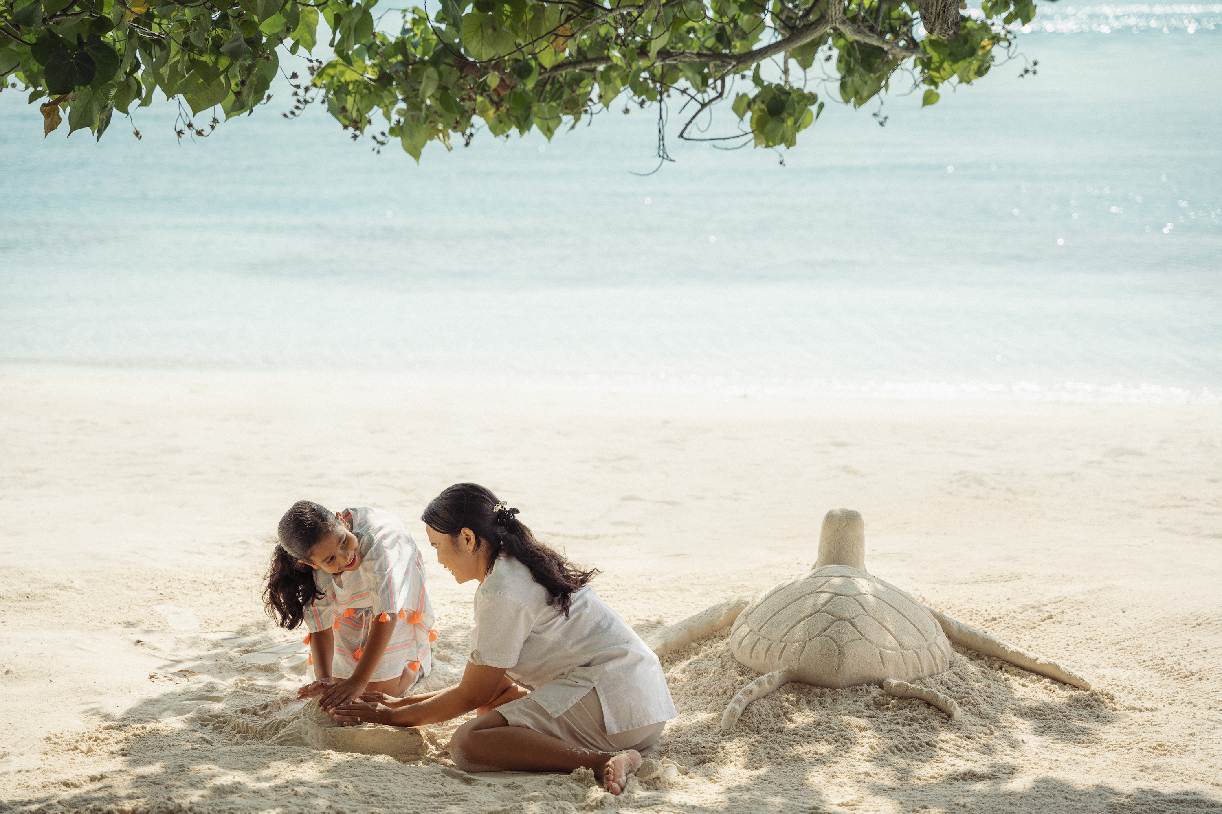
Genuine care from a heartfelt team. Oceanic family-inspired living spaces. Thrilling marine magic that expands horizons. Whether you’re plunging into lagoon-based PADI dive lessons (ages 8+) or sharing stories over a starlit beach BBQ, Four Seasons Resort Maldives at Kuda Huraa is dedicated to weaving warmth and wonder into every family getaway.
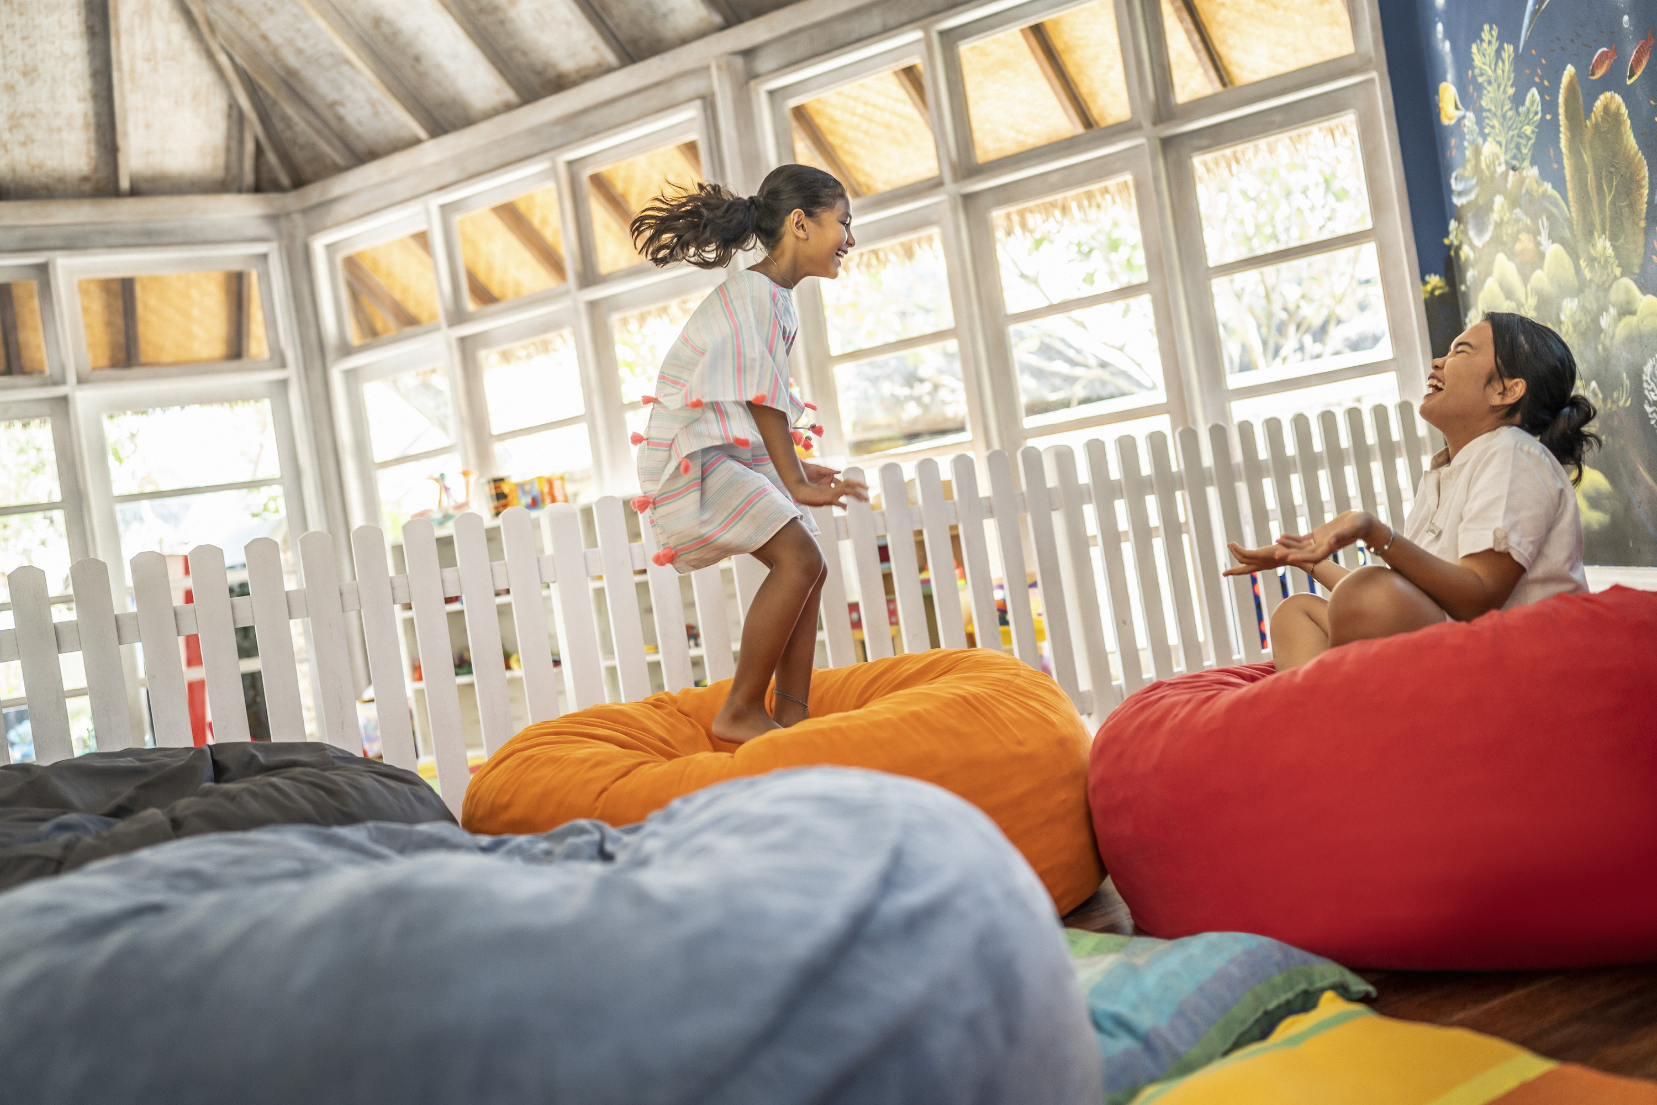 | 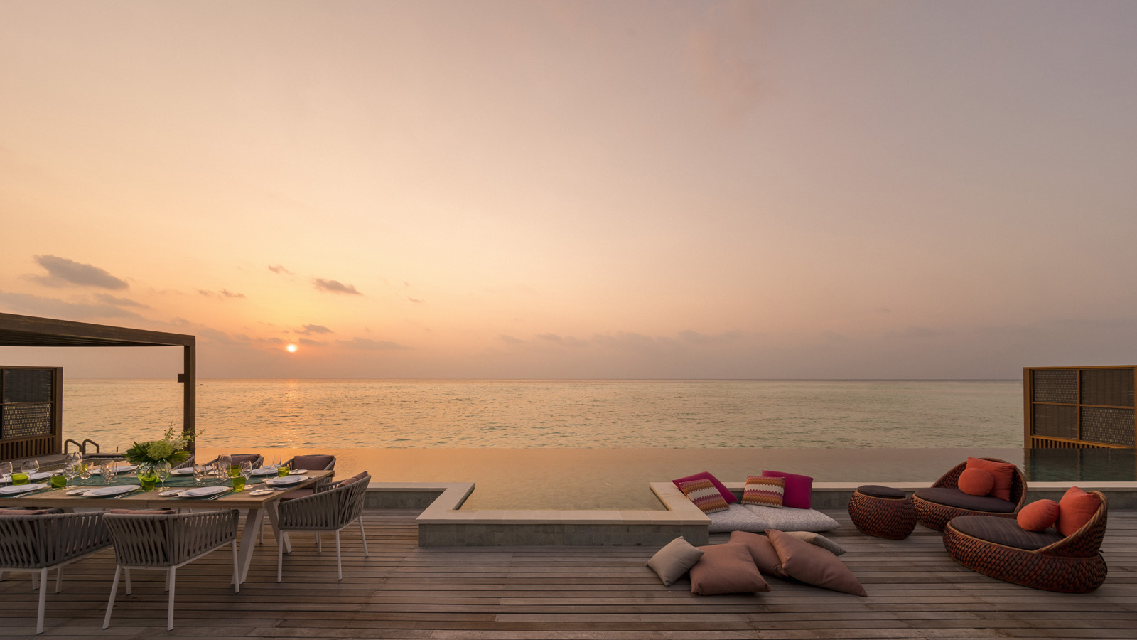 | 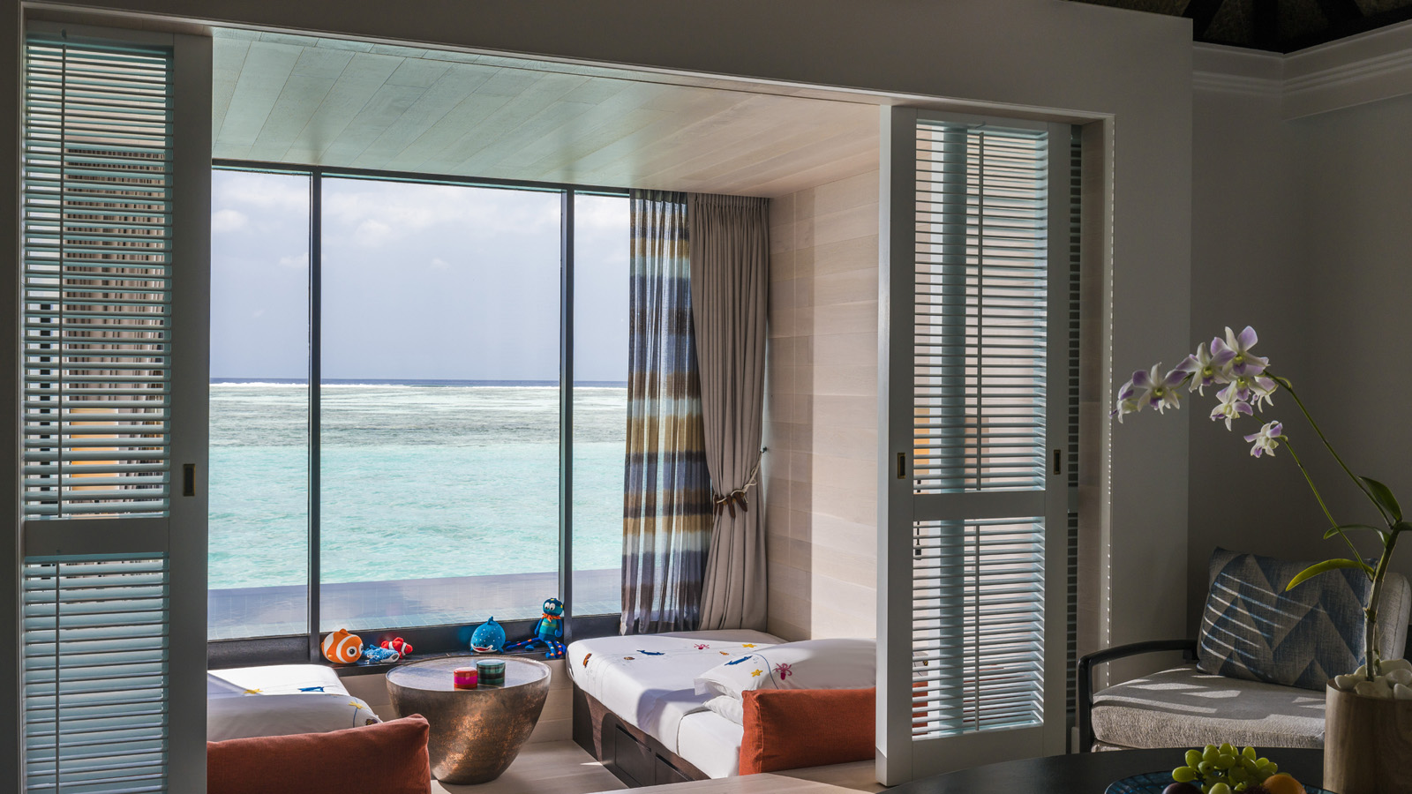
Discover five ways Kuda Huraa is a haven for families:
1. The Home-From-Home Welcome
Legendary warmth sets the tone from the moment of arrival at Kuda Huraa. Rooms, suites, restaurants and facilities convene village-style around a central garden promenade for convenient family living with everything close at hand. Smoothing every ripple for stress-free travel, the compassionate team – many of whom have been at Kuda for more than 20 years – are on hand to share the wonders of their island with guests young and old.
2. Soaring Sea-View Spaces
Open plan living steps from white sands. Free-form plunge pools and tropical gardens. Overwater hammocks and infinity pools. From getaways for three to big multigenerational vacations, Kuda Huraa’s oceanic accommodation options enable families of every size to artfully combine playful moments with meaningful downtime.
3. Cultivating Wonder and Inspiring Tomorrow’s Changemakers
Forget stuffy classrooms – our immersive onsite experiences cultivate a sense of wonder you won’t find in any textbook: lagoon-based PADI dive lessons open up a world of underwater magic for kids as young as eight; little grommets aged six and above can learn from Tropicsurf coaches in the crystal lagoon; Junior Marine Savers experiences offer hands-on conservation insights from helping to care for injured turtles to planting a coral reef with marine biologists.
4. Building Unbreakable Bonds
Meaningful memories await with “family play” activities made for sharing. Sail into the sunset to learn the skill of Maldivian handline fishing. Create – and devour – a homestyle Indian feast with a Baraabaru cookery class. Board a dolphin cruise to spot local pods playing in the waves. Wander sandy streets, peruse handicraft stalls and soak up the timeless culture of the Maldives with a local island tour or relax into togetherness with a shared spa treatment at The Island Spa, accessible via a ride in a tiny wooden dhoni boat.
5. Reassuring Care – As Standard
From the Kuda Mas kids-only zone with its daily program of complimentary activities to free meals for under-fives, thoughtful Four Seasons touches ensure a stress-free stay for parents craving well-earned downtime. Treats for the wee ones include child-size robes and slippers, goodie bags and toiletries, while special meal requests and early restaurant sittings make dining with kids a breeze.
For magical Maldivian family memories at Four Seasons Resort Maldives at Kuda Huraa, email reservations.mal@fourseasons.com or call the central reservations department of Four Seasons Resorts Maldives at tel: (960) 66 00 888.

RELATED

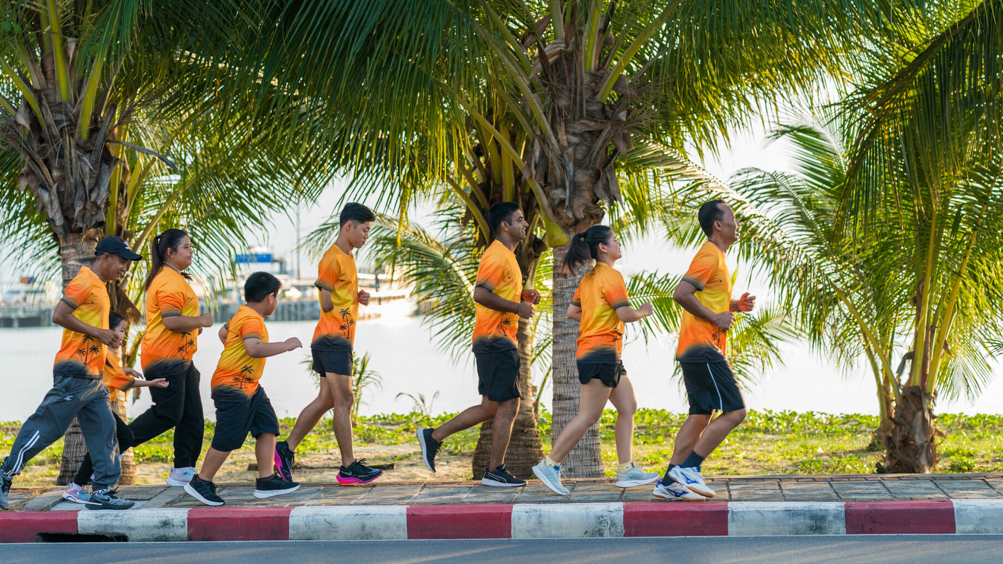 | September 19, 2024, Koh Samui, Thailand  Four Seasons Resort Koh Samui Announces Annual Cancer Care Charity Fun Run  https://publish.url/kohsamui/hotel-news/2024/cancer-care-fundraiser.html
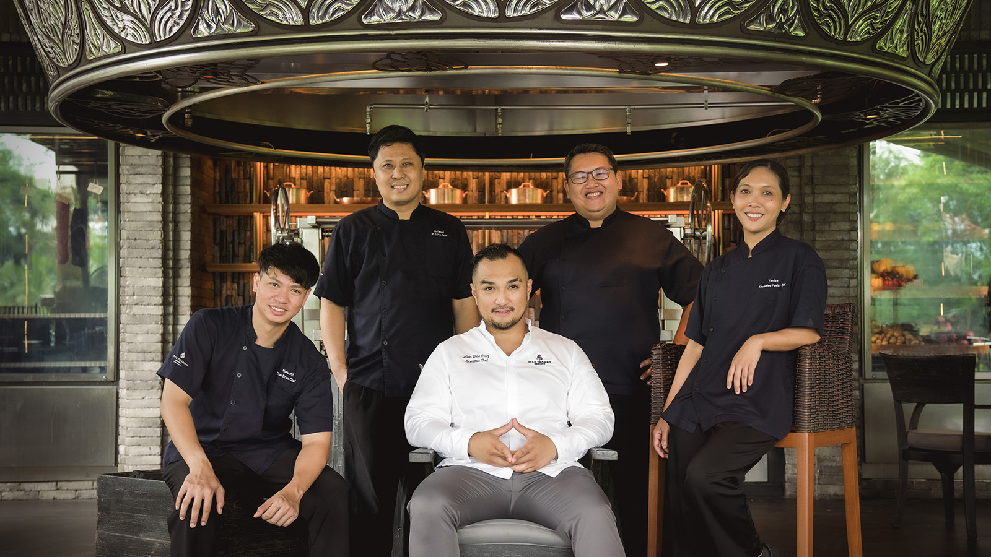 | September 18, 2024, Chiang Mai, Thailand  Four Seasons Chiang Mai: A Culinary Journey Through Northern Thailand's Seasonal Delights  https://publish.url/chiangmai/hotel-news/2024/culinary-destination.html

PRESS CONTACTS

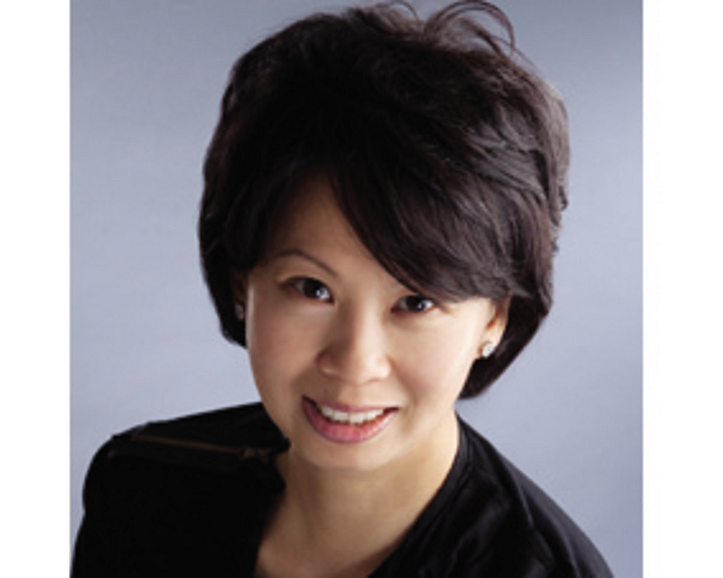 | Juliana Ang  Senior Director of Public Relations and Communications  Tourism Court, #04-00, 1 Orchard Spring Lane  Singapore  247729  juliana.ang@fourseasons.com  (65) 6514 82 81

